Grade 3, Unit 8 Study Guide
Name __________________________

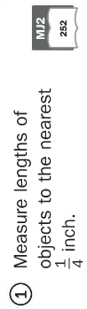 | 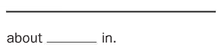  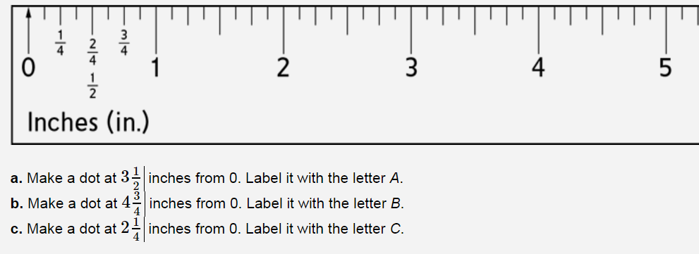
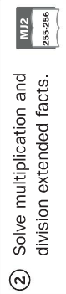 | 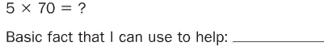  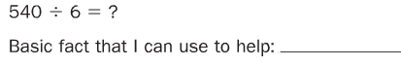  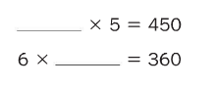
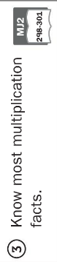 | 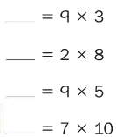
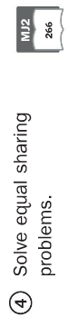 | You have $10 and $1 bills.  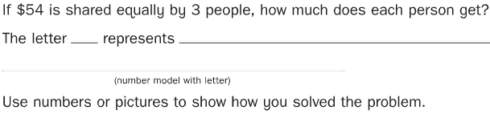
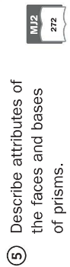 | Explain why this shape is a triangular prism.  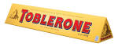  ___________________________________________________________________________________________________________________________________________________
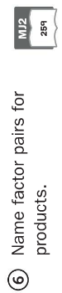 | 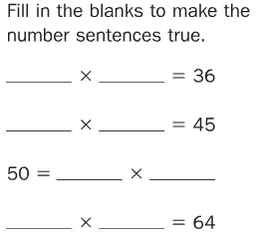  Here is a game mat for Factor Bingo. You draw a 3 card. Circle at least 3 products with a factor of 3.  