Name _____________________________
Unit 1 Review

- Use a number grid

The difference between 25 and 87 is __________.

The difference between 89 and 110 is __________.

The difference between 98 and 123 is __________.

Explain how you used a number grid to solve the first problem. _______________________

_____________________________________________________________________________

_____________________________________________________________________________
- Write the time shown on each clock.

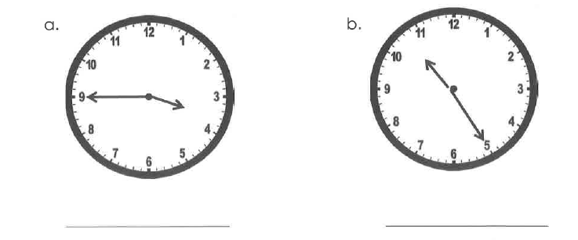
- Use the tally chart to complete the bar graph.

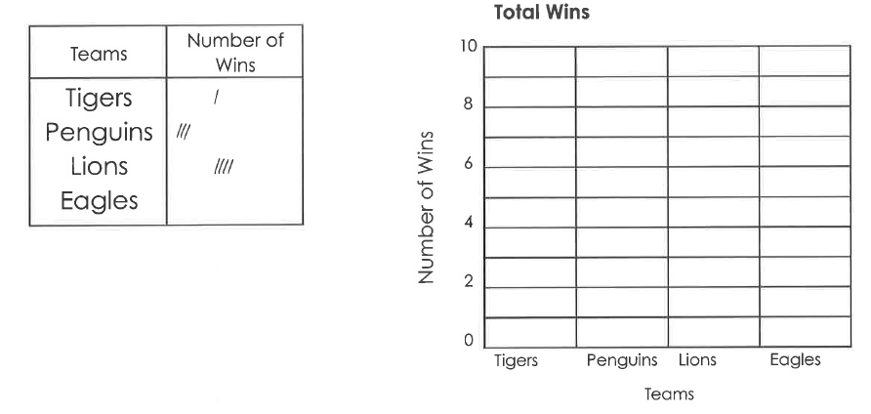

How many more wins did the penguins have than the tigers? __________

How many total wins did the teams have in all? __________

- Solve each problem.

6 x 2 = __________ 3 x 3 = __________ 9 x 2 = __________

2 x 4 = __________ 10 x 4 = _________ 3 x 4 = __________

5 x 3 = __________ 3 x 6 = __________ 5 x 5 = __________

How did you solve 5 x 3? __________________________________________________________

_______________________________________________________________________________

_______________________________________________________________________________

- For the number story, draw a sketch and write the answer.
Then write a number model to fit the story.

Mary has 3 packs of gum.
In each pack there are 5 pieces.
How many pieces of gum does she have in all?

She has __________ pieces of gum.

Number model: ___________________________________________________________
- John starts soccer practice at 3:55 p.m. and finishes at 4:40 p.m. He drew an open number line and used it to find the length of his practice.

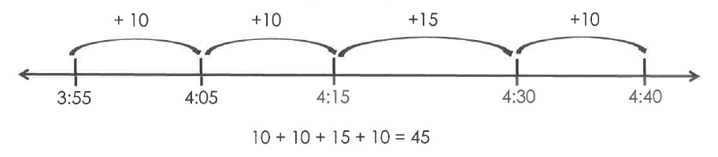

Explain John’s work. ________________________________________________________

_________________________________________________________________________

How long is John’s soccer practice? __________ minutes long

- Round each number to the nearest 10.
Use the open number lines to help.

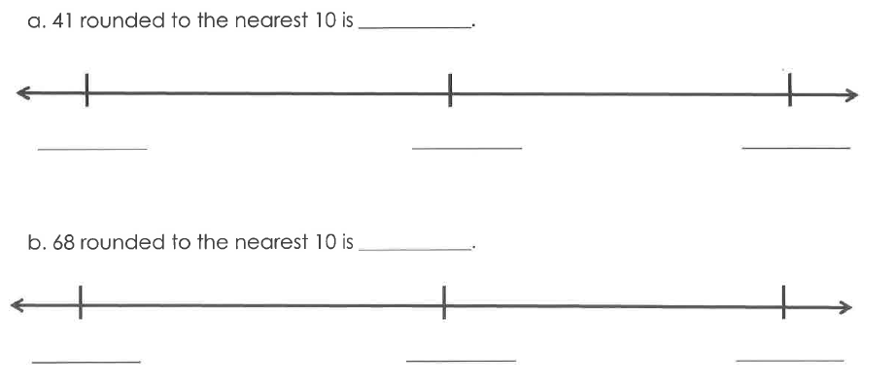
- Round each number to the nearest 100.
Use the open number lines to help.

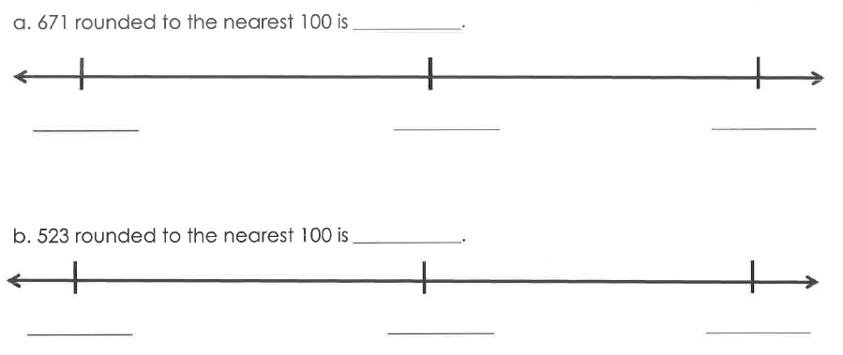
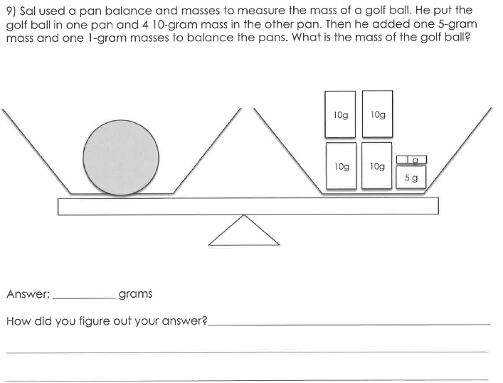
Open Response Assessment

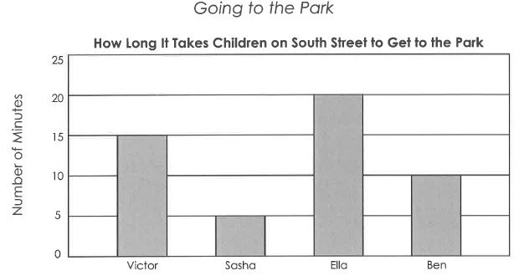

Look carefully at the title, labels, and bars on the graph. Write at least 5 things you know from the graph.

