Skill: Represent and interpret data using tally charts, tables, pictographs, line plots and bar graphs.
a. Use the tally chart to create a bar graph.
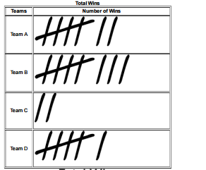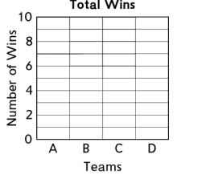

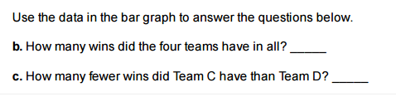
d. Explain how you found how many fewer wins Team C had then Team D.
______________________________________________________________________________________________________________________________________________________________________________________________________________________________________________________________

Skill: Represent and solve problems involving multiplication and division.
For each number story, draw a sketch and write the answer. Then write a number model to fit the story.
- Ron has 2 fish tanks. In each fish tank there are 8 fish. How many fish does Ron have in all?

- Luna reads 9 pages in her book. It takes her 4 minutes to read each page. How many minutes does she read in all?

Skill: Tells and writes time to the nearest minute and solve problems by calculating time intervals.
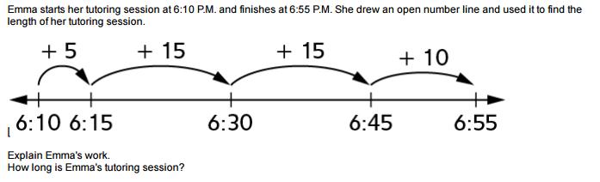

Skill: Rounding numbers to the nearest 10 and 100.

